**Reference No:** C13…..

**Damage Report Date:** .15/07/13...

**Incidents must be reported immediately.**

Damage found in Container must not to be touched until pictures have been taken to effectively demonstrate to stake holders how damage could have occurred?

In Container Container No. TRLU8684709

In Warehouse How was it damaged?

Product

PSRE343 S/N = YBTL03002

*Insert* Picture:

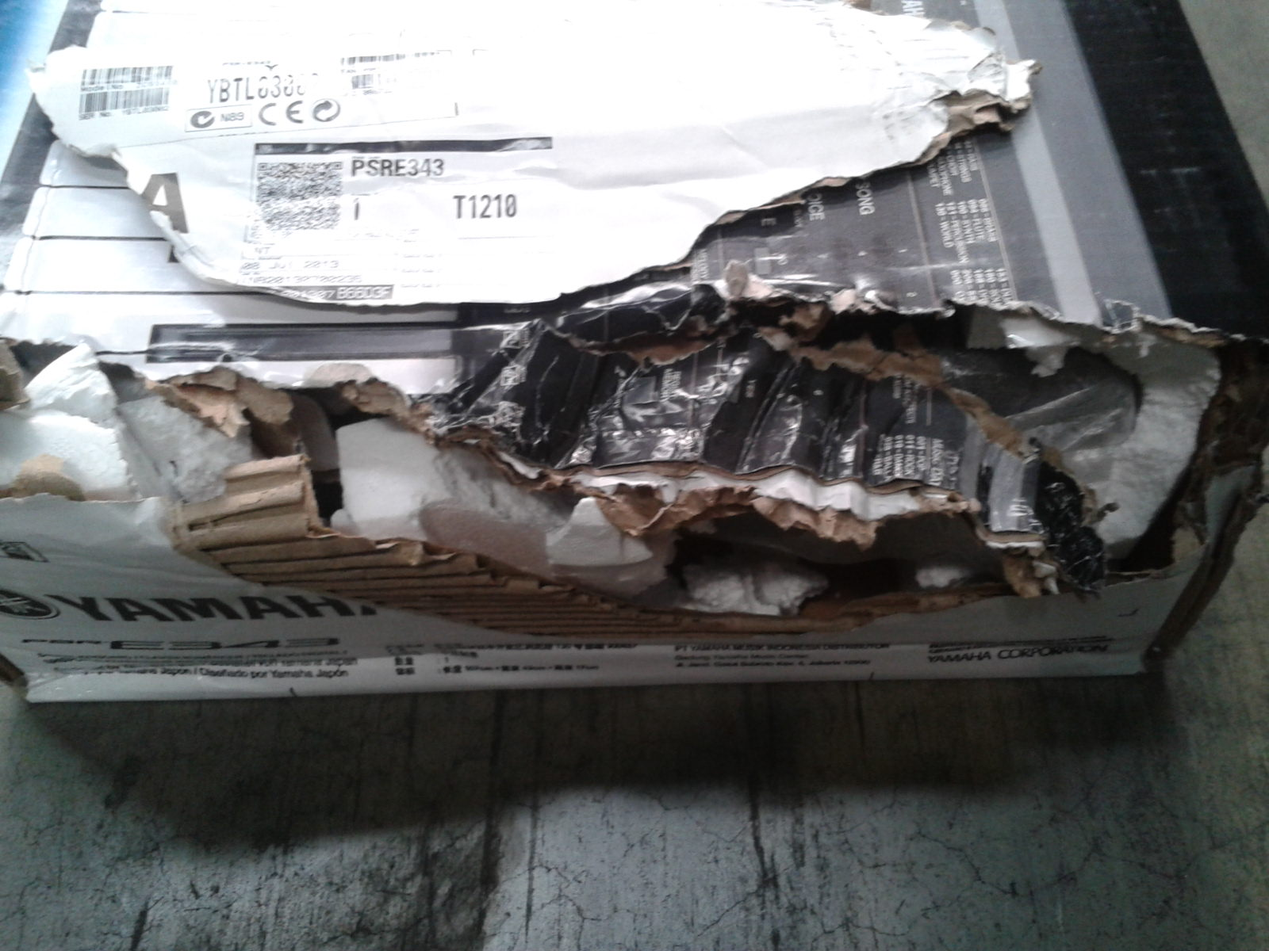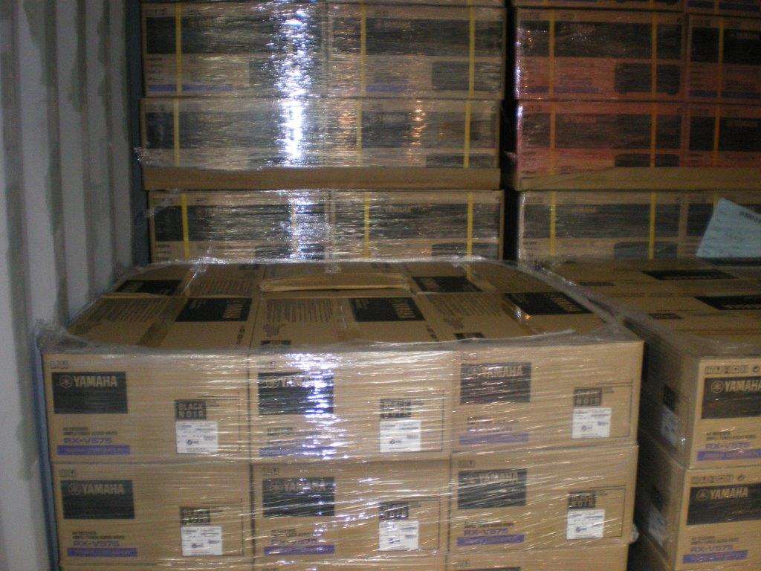

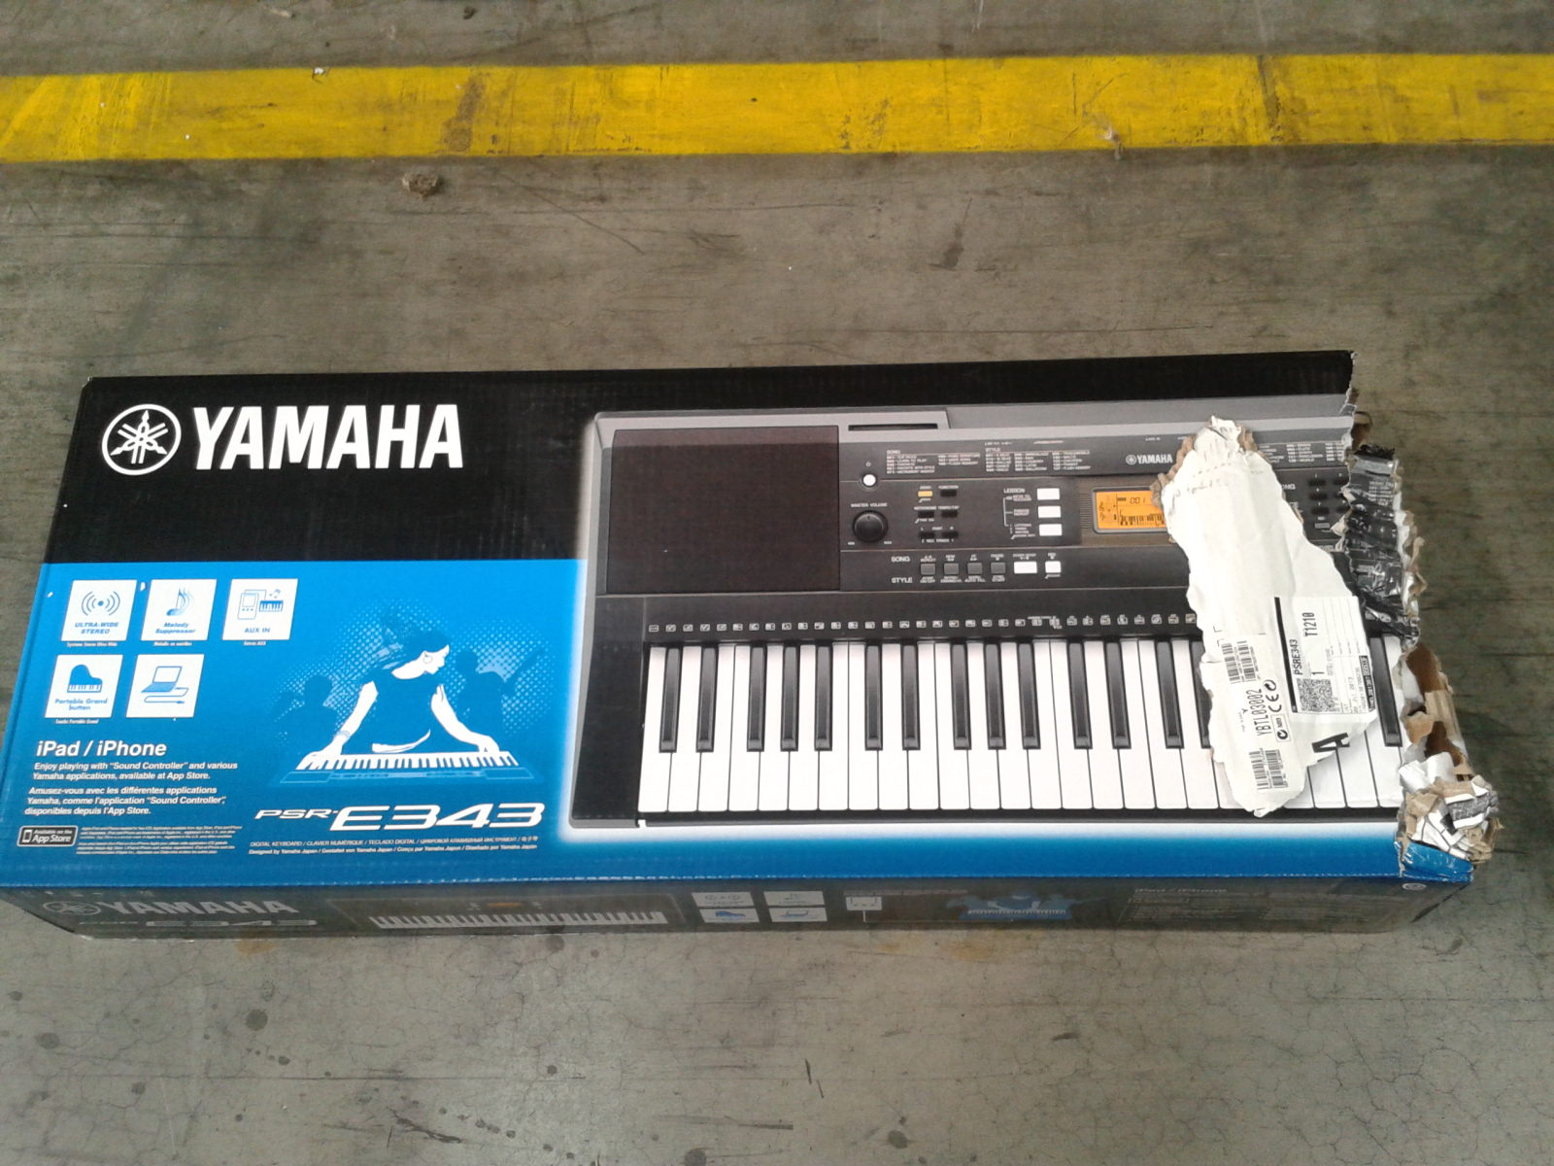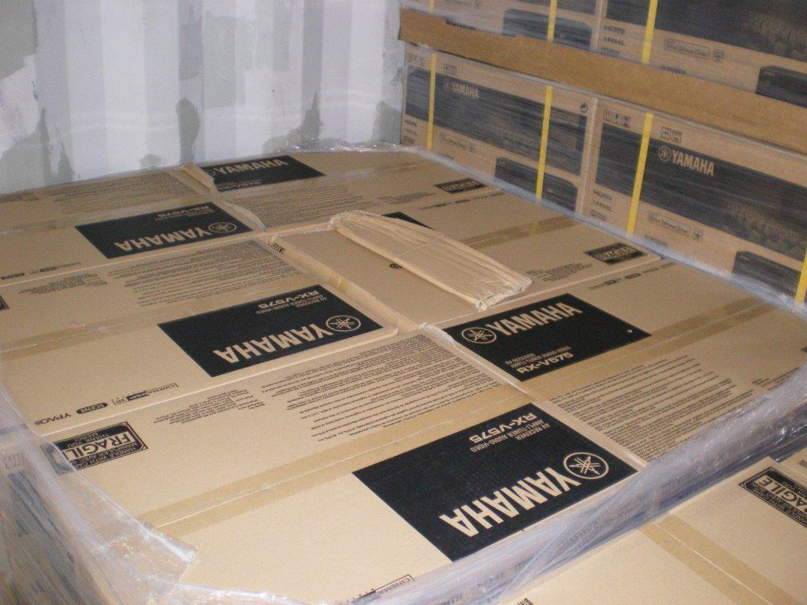

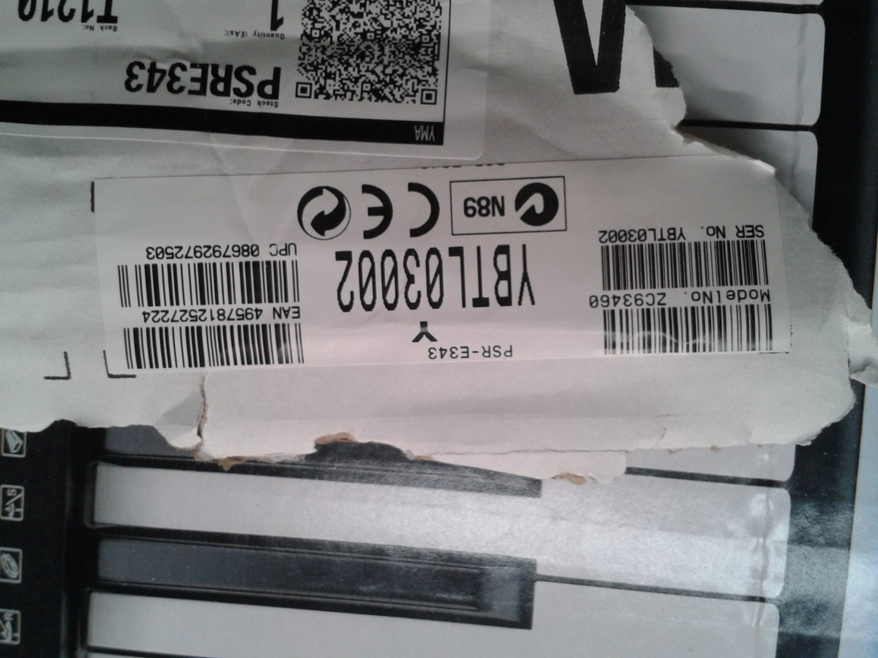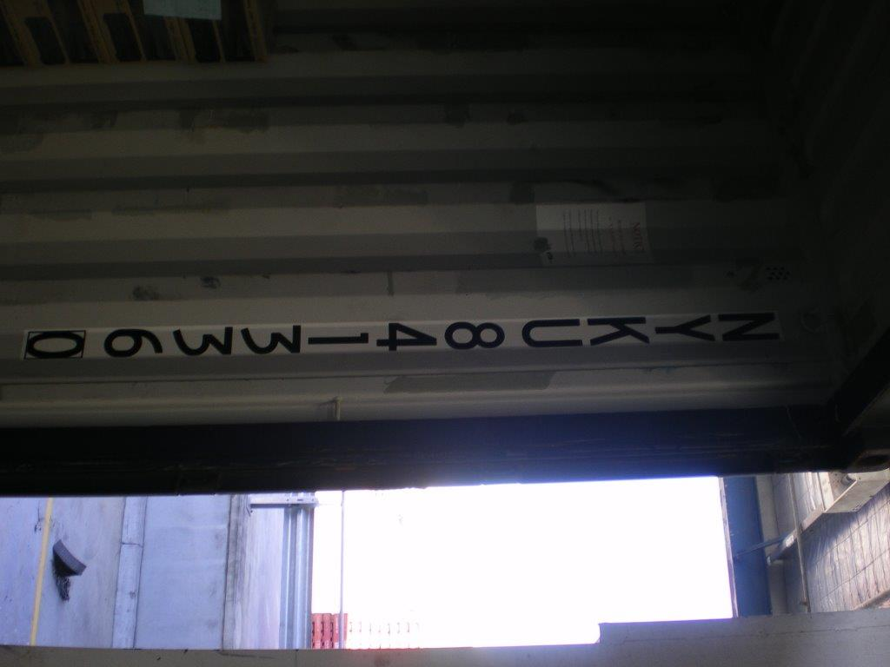

Reported by…… Frank Vastag ……………………………………….